FIRST BAPTIST CHURCH CROSSNORE

February 16, 2025

Welcome and Announcements Jeremiah Parker

Appreciation for Pastor Jeremiah Randall Aldridge

Worship Song “The Solid Rock” Page 511

Worship Song “Amazing Grace (My Chains are Gone)”

Worship with Tithes and Offerings (Prayer: Bobby Daniels)

Children’s Sermon Jeremiah Parker

Choral Music “Grace that Won’t Let Go” Choir

Message Jeremiah Parker

Response “Lord, I’m Coming Home” Page 634

Benediction

Nursery is provided for your children birth through 2 years of age and toddlers ages 3 and 4. It is our hope that you will take advantage of this special service. If you are visiting with us and have need of the nursery, please ask for directions.

Serving God in the Nursery

**This Morning:** Phillip and Renee Barrier,

Lisa Daniels, Tammy Costner

**Sunday Night:** Rose Gates and Eula Johnson

**Wednesday Night:** Carolyn Parsons and Emma Wiseman

**Next Sunday:** Alice McKinney, Frances Henline,

Peggy Howell, Marsha Hosey

Sunday School Attendance last week: 106

*you can give online via our church website: firstbaptistcrossnore.com*

**Deacon of the Week:** Bobby Daniels

**Next Week:** Dustin Haigler

Greeters/Welcome Center:

This Week: Bobby and Lisa Daniels

Next Week: Dustin and Olivia Haigler

This Week……

**Sunday** 6:00pm—No Evening Worship

**Wednesday** 7:00pm—Bible Study and Business Meeting

7:00pm—King’s Kids

7:00pm—Valley Students

8:00pm—Choir Practice

**Thursday** 9:00am—Men’s Prayer Time



**Prayer Corner:** Haley Carroll, Shanielle Calloway, Monique Alva, Lynn Woodie, Erin Carver, Anna Ledford, Genesis McClain, Vickie Ollis, Kathy Vance Benfield, Ann Henson, Eddie Hughes,Brian and Meredith Harmon, Tracy Hoilman, Dennis Gragg, Regina Henson Hood, Garrett Henson, Shannon and Chesney Triplett,Shirley Lowe, Lisa Keaton, Lisa Thomas,Chase Clark, Shannon Purdue, Kenny Wise, leaders, military, missionaries, the unsaved.

**\*\*If you have a name to add to the Prayer Corner, please call the church office (828-733-5243).**

E Fall Gathering of the Avery Bapst Associaon will be held here at 6 PM on October 5

th

.

We will have the deacon ordinaon service for Je#ery Pollard and Mitchell McKinney at 11 AM

September 27

th

.

Harvest

The Fall Gathering of the Avery Bapst Associaon will be held here at 6 PM on October 5

th

.

We will have the deacon ordinaon service for Je#ery Pollard and Mitchell McKinney at 11 AM

September 27

th

.

Harvest



February 18, Jeremiah Clark; Feb. 19, Pam Johnson;

Feb. 20, Frances Henline, Paul Bentley; Feb. 21, Becky Rominger; Feb. 24, Samuel Gates

Welcome First Time Visitors! Please pick up your gift and packet from the greeters in the vestibule.

There is a sign-up sheet on the table at the back of the sanctuary if you would like to provide food for the youth on Wednesday nights.

2025 Youth Summer Camp

Deep Impact

Hendersonville, NC

June 23-27

Please sign up with a nonrefundable $100 deposit by Wednesday, March 26th.

**Today, we honor and show our appreciation for our Pastor and his family. A hamburger/hot dog meal will be served in the gym following the service, everyone welcome. We will be taking a Love Offering for Pastor Jeremiah during the worship service today. Also, there will be a basket at the meal for cards. Join us as we show our love and appreciation to our Pastor!**

*Valley Students…mark your calendars!*

*Youth Night, Friday, March 28th*

*Worship, Food, Field Games, and more*

*Victory Baptist Church, Denver, NC*

We will have a Baby Shower for Daniel and Brittany Henson *next Sunday, February 23rd*, following the evening worship service. Ladies, please bring finger foods. It’s a BOY!

Please note that we will be taking the Birthday Offering next Sunday during morning worship.

There is a basket in the vestibule to place gift cards for newlyweds Alyssa Parsons Kollar and Vinny Kollar. Please bring gift cards by Sunday, March 2nd, as we celebrate with the couple as they begin their new life together.



**February 21st & 22nd**

**First Baptist Church, Crossnore**

**Please sign up at the back of the sanctuary today so we can plan accordingly.**

**..**

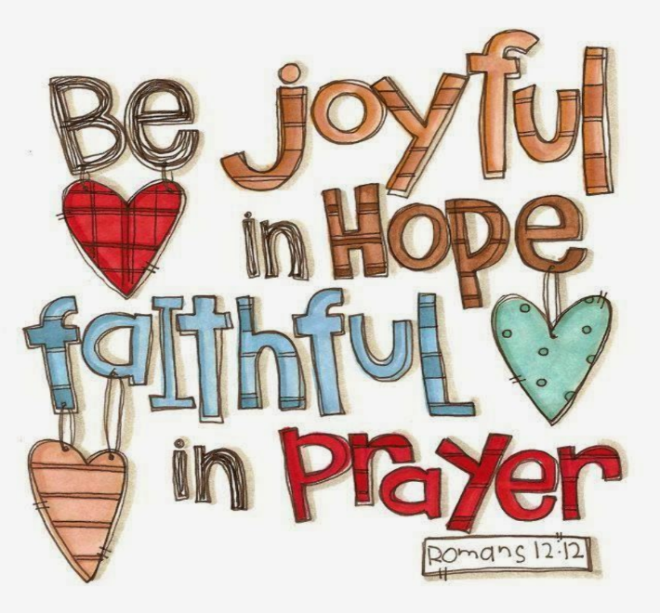

*FIRST BAPTIST CHURCH CROSSNORE*

*PO Box 370*

*Crossnore, NC 28616*

*Church Office: 828-733-5243*

*Website: firstbaptistcrossnore.com*

*Office Hours: Monday-Friday 8:00am-3:00pm*

*Senior Pastor:*

*Pastor Jeremiah Parker (Cell: 828-291-8279)*

*Administrative Assistant: Renee Gouge*

*Music Director: Tara Andrews*

*Pianist: Stephanie Watson*

*Chairman of Deacons:*

*Mr. Randall Aldridge (828-260-5820)*

*Prayer Chain Numbers:*

*Kathy Aldridge 828-733-9613 or 828-260-3199*

*Kay Grubb 828-733-6431 or 828-387-6994*

*Our Mission Statement at First Baptist Church, Crossnore is:*

*“To glorify God together in ministry by prayerfully living by His Word and sharing the Gospel of Jesus Christ through missions."*

